|  |
| --- |
| ­­­­­The Astonishing Universe: |
| C:\Users\Bache\AppData\Local\Temp\{98BF8399-CB8C-4524-91F8-6CE6CF1010A8}.tmpExploring Science, Space, Spirituality, and Hindutva Perspectives |
|  |

­­­­­

# Index (Draft)

**Chapter 1: The Amazing Start** – 15-20 page

* Big Bang: How did everything begin? (2-4 page)
* Creation of Elements: Discover how elements were formed. (4-5 page)
* First Stars: Meet the stars that lit up the Universe. (3-4 page)
* Recombination: Understanding the process of recombination. (2-3 pages)
* Reionization: Explore the colorful transformation of the Universe. (3-4 pages

**Chapter 2: Exploring Our Universe -** 25-30 pages

* Stars and Constellations: Journey through the night sky. (5-6 pages)
* Galaxies and Black Holes: Unveil the secrets of the cosmic giants. (6-7 pages)
* Moons and Planets: Visit the diverse worlds in our Solar System. (5-6 pages)
* Nebulas and Gamma Rays: Marvel at the vibrant celestial clouds. (4-5 pages)
* White Holes and Wormholes: Embark on a journey through space and time. (4-5 pages)

**Chapter 3: The Tiny Quantum World** - 20-25 pages

* Light: Wave or Particle? Unravel the mystery of light. (6-7 pages)
* Atoms and Gravity: Explore the building blocks of matter and the force that keeps us grounded. (6-7 pages)
* Time and Relativity: Dive into the fascinating concept of time. (5-6 pages)
* Energy: Discover the powerful force that drives the Universe. (4-5 pages)

**Chapter 4: Theories and Wonders** - 20-25 pages

* Theory of Relativity: Join Einstein's groundbreaking ideas. (6-7 pages)
* Quantum Theory and Basic Particles: Venture into the quantum realm. (6-7 pages)
* Theory of Everything: Seek the ultimate understanding of the Universe. (5-6 pages)
* String Theory and Space-Time: Explore the fabric of the cosmos. (5-6 pages)

**Chapter 5: Mysteries of the Universe** - 20-25 pages

* Are We Alone? Question the existence of extraterrestrial life. (5-6 pages)
* Quantum Entanglement: Dive into the peculiar phenomenon of entangled particles. (4-5 pages)
* Dreams and Massless Objects: Uncover the mysteries of the mind and the ethereal world. (5-6 pages)
* Afterlife: Contemplate the possibilities beyond our earthly existence. (4-5 pages)

**Chapter 6: Science vs Spirituality** - 30-35 pages

* Science and Beliefs(4-5 pages)
* Finding Meaning (4-5 pages)
* Mind and Emotions (4-5 pages)
* Connectedness in Nature (3-4 pages)
* Ancient Wisdom (4-5 pages)
* Inner Peace and Clarity (3-4 pages)
* Alternative Approaches to Well-being (4-5 pages)
* Ethics and Values (3-4 pages)
* Expanding Awareness (3-4 pages)
* Respecting Nature (3-4 pages)

**Chapter 7: Hindutva Ideology and the Universe** - 25-30 pages

* Exploring the Universe through a Hindutva Perspective (4-5 pages)
* Concepts of Time in Hindutva Philosophy (4-5 pages)
* Connections between Hindu Cosmology and Scientific Understanding (5-6 pages)
* Reinterpretation of Scientific Theories from a Hindutva Lens (4-5 pages)
* Intersections of Spirituality and Science in Hindutva Thought (4-5 pages)
* Hindutva Views on Creation, Evolution, and Cosmic Order (5-6 pages)
* Influence of Hindutva Ideology on Environmental Conservation (4-5 pages)
* Critiques and Debates surrounding Hindutva's Approach to the Universe (4-5 pages)
* Exploring Diverse Interpretations of the Hindu Tradition (4-5 pages)
* Building Bridges between Hindutva Ideology and Scientific Community (4-5 pages)

**Preface**

We, the authors of this book, have made this creation keeping in mind that whosever it be, a person of 1st class or a student of 12th class has an interest in astrophysics, in space, in time, and the whole world of quantum mechanics and physics, who are related to dharma and science both at the same time, reads this book, must be assured that whatever he is reading is uneasy to forget and is a boom for a person who is just a beginner in this field. We started writing this book when we were in our early stages in this field. Two newbies start writing about what they explored slowly in this world and questioned themselves: Who, Why, Where, Us? What is god, and how this all started, what was there before the starting, and what is the basics code of this astonishing universe, and millions of other questions start coming to our mind when we start thinking about it, as simple key is : to meditate everyday, at least 5 minutes. That inner peace of hymn just answers us to live the way we want, truly, as a social being our duty is to just live life with good karmas. Rest of the questions would be answered to us on time. Starting our the journey of these astonishing univers, hold tight and get ready to imagine the scenes of the universe from begin to end…

**~ Dhruv**

**~ Parvanshu**

**~ Arnav**

**~ Bhumi**

**~ Shivansh**

**Story Begins…**  Once upon a time, a long, long time ago, there was nothing in the universe, not even space or time. Then, all of a sudden, something happened that changed everything - it was called the Big Bang.

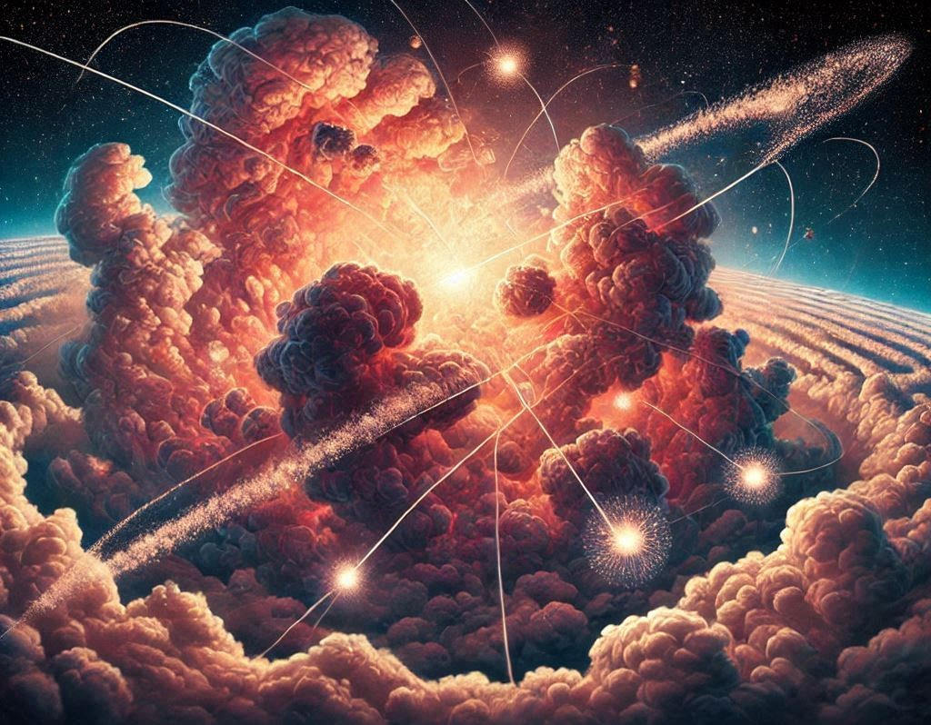The Big Bang was like a giant explosion that created everything we know today - the stars, the planets, and even you and me! Before the Big Bang, all matter in the universe was compressed into an infinitely small point, known as a singularity.

After the Big Bang, the universe started to expand rapidly, like a balloon being inflated. The energy and matter from the explosion cooled down and started to form particles, which eventually became the building blocks for everything in the universe.

As the universe continued to expand, gravity started to pull matter together, forming giant clouds of gas and dust. These clouds started to collapse in on themselves, and the pressure and heat inside caused nuclear fusion, creating the first stars.

These stars were different from any that exist today - they were made purely of hydrogen and helium. Over time, these stars used up all their

fuel and eventually exploded, scattering their elements throughout the universe.

This created heavier elements like carbon, nitrogen, and oxygen. These elements would eventually become the building blocks for.

As the universe continued to expand, it started to cool down, and the first atoms formed. This allowed light to travel freely through the universe, creating the cosmic microwave background radiation we can still detect today.

As time passed, galaxies formed, and the first stars died. This process, known as reionization, led to the formation of more complex elements and the birth of new stars and planets.

And so, the universe continued to evolve and change, creating new wonders and mysteries to explore. The study of astrophysics helps us to understand the incredible journey of the universe from the Big Bang to the present day.

So this is a long story short of the starting to the present of our universe.

Now we are going to take a deep dive into this astonishing universe of astrophysics with the help of this roller coaster in the form of a book.

**Chapter 1: The Amazing Start**

Introduction: Unveiling the Wonders of the Universe

Welcome to an incredible adventure through the mysteries of the universe! Have you ever wondered how everything around us came to be? How did our vast universe come into existence? Get ready to explore the awe-inspiring story of the cosmos, from its remarkable birth to the creation of stars, galaxies, and more.

In this chapter, we will dive into the Big Bang, a tremendous explosion that sparked the birth of our universe. We'll uncover how elements like hydrogen and helium were formed, like the building blocks of everything we see. Imagine the universe as a giant puzzle, with pieces coming together to create majestic stars and galaxies.

But our journey doesn't stop there. We'll witness an incredible moment called recombination, when the universe transformed from a hot, chaotic state to a cool, transparent cosmos. Imagine it like a cosmic light switch being turned on, revealing the wonders of space. We'll also meet the first stars, the dazzling pioneers that brought light to the darkness.

Hold on tight as we discover the enchanting process of reionization, when the universe burst into a burst of colors and energy. It's like a fireworks show, with galaxies and cosmic structures emerging in a dazzling display.

Get ready to be amazed by the forces that shaped our universe and paved the way for life to exist. Science and wonder will join hands as we unravel the secrets of how it all began.

**1.1 Big Bang:** Imagine looking up at the night sky, filled with countless stars, and wondering how it all began. Scientists have been curious about this too, and they have come up with a fascinating idea called the Big Bang theory.

Before we dive into the Big Bang, let's talk about what a theory is. Just like when you're putting together a puzzle, scientists gather lots of clues and evidence to form theories. They study the universe and gather information using powerful telescopes and experiments. They look for patterns and connections in the evidence, like puzzle pieces fitting together, to create a picture of how things happened.

Now, let's journey back in time to when the universe was just starting. According to the Big Bang theory, the whole universe was once compressed into a tiny, incredibly hot and dense point. Suddenly, this point started expanding rapidly, and everything we know and see today began to form.

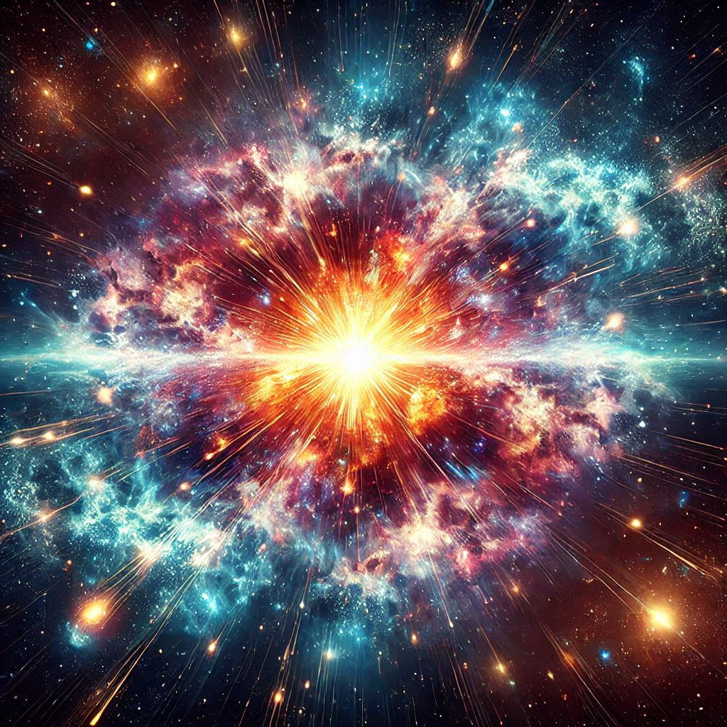As the universe expanded, it cooled down. Imagine blowing up a balloon – as it gets bigger, it also cools down. This expansion and cooling allowed particles like protons, neutrons, and electrons to form. These tiny building blocks are the foundation of everything in the universe.

After some time, the universe became a bit cooler, and something magical happened. The protons, neutrons, and electrons started coming together to create atoms. Atoms are like the letters of an alphabet that can combine to form all sorts of things, like stars, planets, and even you and me!

As the universe continued to expand, gravity began to work its magic. Gravity is like a force that pulls things together. It brought atoms closer and closer, causing them to form clouds of gas. These gas clouds started collapsing under their own gravity, getting denser and hotter. In some of these collapsing clouds, stars were born.

Stars are like gigantic balls of hot, glowing gas. They produce their own light and heat by fusing atoms together in a process called nuclear fusion. This is similar to how a campfire produces heat and light by burning wood. Stars are the powerhouses of the universe, creating elements like hydrogen, helium, and even heavier ones like carbon and oxygen.

But the story doesn't end there. Inside these stars, there was an incredible cosmic recipe going on. When massive stars reach the end of their lives, they explode in spectacular supernova events. These explosions spread the elements they created, like cosmic stardust, throughout the universe.

This stardust, made up of various elements, eventually came together to form new stars, planets, and even you and me. So, in a way, we are all made of star stuff!

The Big Bang theory helps us understand how our vast universe came into existence. It's like a cosmic puzzle that scientists have pieced together based on their observations and experiments. While we may never know exactly what triggered the Big Bang or what existed before it, this theory provides us with a remarkable explanation for the origins of the universe.

As we gaze up at the night sky, filled with twinkling stars, we can appreciate the grand story of the Big Bang. It's a story of an incredible explosion, the formation of atoms and galaxies, the birth and death of stars, and the creation of everything we know and love.

So, the next time you look up at the stars, remember that you are witnessing the remnants of a cosmic event that happened billions of years ago. The universe is an amazing place, and the Big Bang theory allows us to glimpse its incredible beginnings.

The Big Bang theory is an extraordinary scientific idea that explains how our vast universe came into existence. It suggests that the universe began as an incredibly hot and dense point, unimaginably small. Then, in a magnificent explosion, it rapidly expanded, creating space, time, and all the matter we see around us. This expansion continues even today.

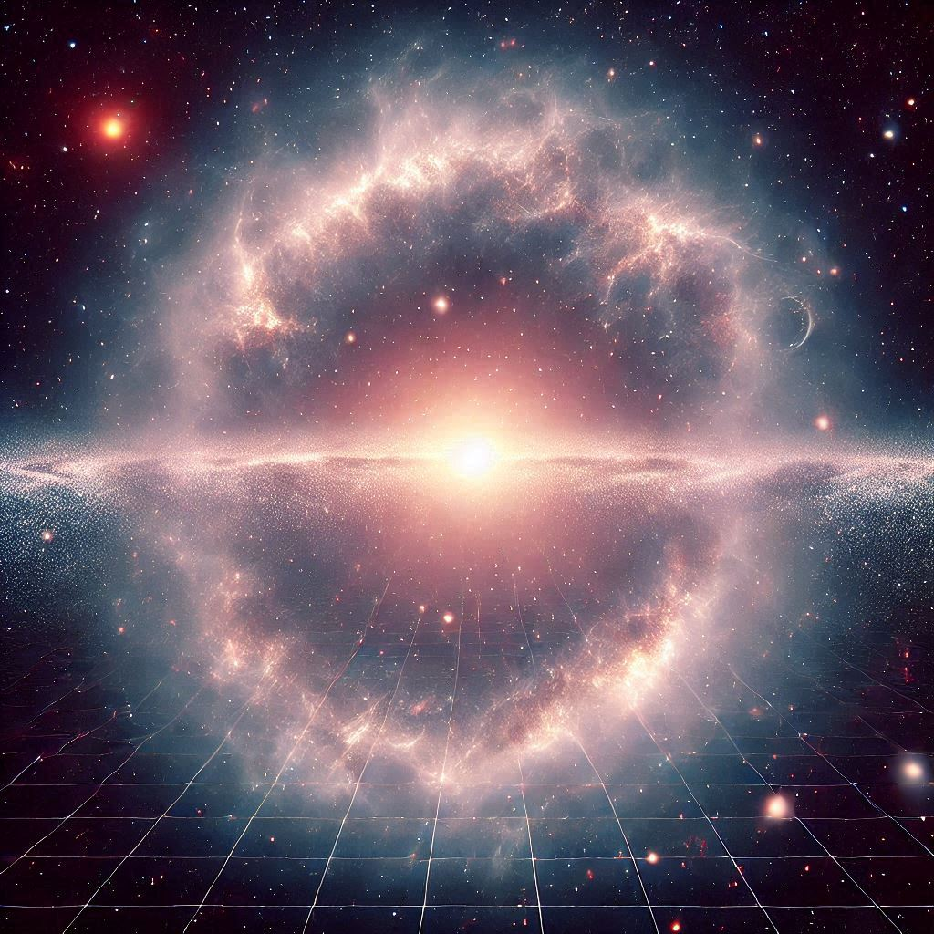Through careful observations and analysis, scientists have discovered evidence that supports the Big Bang theory. They have observed the cosmic microwave background radiation, a faint glow that permeates the entire universe and is a remnant of the immense heat from the early stages of the Big Bang. They have also observed the redshift of galaxies, indicating that the universe is still expanding. We will be knowing about these shifts and radiations later in the book.

The Big Bang theory not only provides insight into the origin of our universe but also helps us understand how galaxies, stars, and planets formed over billions of years. It is a testament to the power of human curiosity and our ability to unravel the mysteries of the cosmos.

**1.2 Creation of elements:** In the aftermath of the Big Bang, the universe was a seething cauldron of energy and matter. But within this chaotic mix, something extraordinary was taking place – the creation of elements.

At the very beginning, the universe was composed of the simplest and lightest elements, such as hydrogen and helium. However, as time passed and cosmic processes unfolded, these basic elements began to transform into more complex ones.

Deep within the heart of stars, a wondrous alchemical process occurred. Stars acted as enormous cosmic furnaces, where the extreme conditions of heat and pressure facilitated the creation of new elements.

Within the searing cores of stars, hydrogen atoms fused together to form helium through a process called nuclear fusion. This fusion released an enormous amount of energy, giving the stars their radiant glow. As the stars burned through their hydrogen fuel, they continued their elemental transformation.

The fusion reactions within the stars produced heavier elements like carbon, oxygen, and nitrogen. These elements are the building blocks of life as we know it. They are the very substances that make up our bodies and the world around us.

But the creation of elements didn't end with stars. Supernovae, the explosive deaths of massive stars, played a vital role in the cosmic alchemy. During these cataclysmic events, the immense energies unleashed triggered the formation of even heavier elements, such as iron, gold, and uranium.

These newly synthesized elements were flung into space, scattered across the universe, ready to participate in the formation of new stars, planets, and even life itself.

From the fiery cores of stars to the dramatic explosions of supernovae, the universe has been tirelessly producing elements, enriching itself over billions of years.

So, when you look up at the night sky and see the twinkling stars, remember that they are not only beautiful but also the creators of the very atoms that make up your existence. You are, quite literally, made of stardust.

Every element in your body, every atom within you, has its origins in the colossal cosmic processes that have unfolded since the dawn of time. You are intimately connected to the vastness of the universe, bound together by the intricate dance of particles and the grand symphony of creation.

As you ponder the night sky, marvel at the incredible journey of elements, from the fiery crucibles of stars to the silent expanse of space. The story of their creation is a testament to the wondrous and ever-evolving nature of our universe.

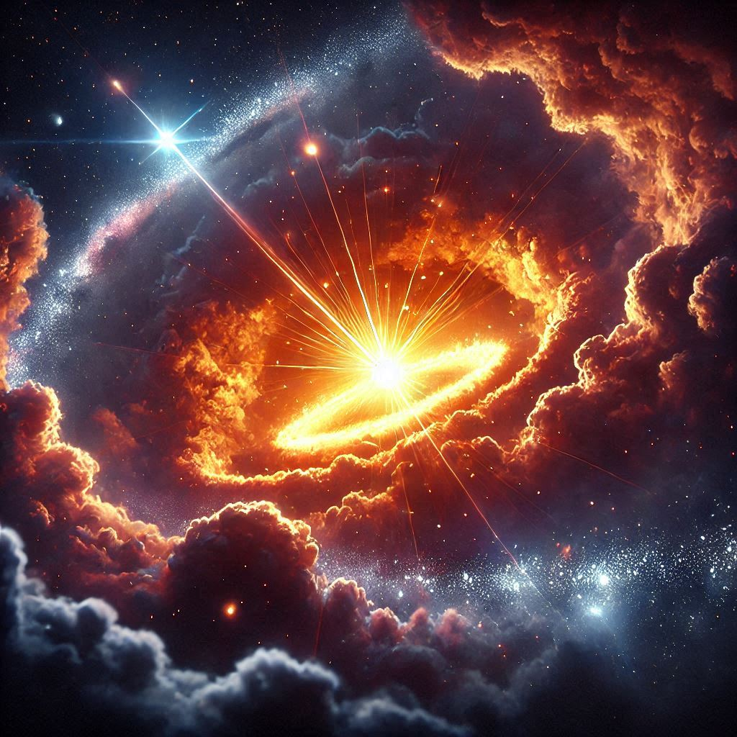

**1.3 First Stars:** Long after the universe was born from the explosive Big Bang, a new chapter in cosmic history was about to unfold. It was the era of the first stars, an extraordinary time when the universe was filled with awe-inspiring celestial bodies that would shape the course of cosmic evolution.

In the vast expanse of space, pockets of gas and dust began to come together, pulled by the invisible force of gravity. These were the nurseries where the first stars would be born. But these stellar nurseries were not like the cozy, cuddly kind you might imagine. They were massive, sprawling clouds of gas and dust, stretching across thousands of light-years.

Deep within these cosmic clouds, something magical was happening. The gas and dust particles were slowly coming together, pulled closer and closer by gravity's gentle embrace. As they drew nearer, their collisions grew more frequent, and the pressure and temperature started to rise.

In the heart of these colossal clouds, a momentous event was about to take place – the birth of a star. As the gas and dust compressed, the temperature soared, triggering nuclear reactions deep within the core. It was as if a cosmic fire had been ignited, illuminating the darkness of space.

The first stars were giants, much larger and brighter than the stars we see today. They burned with an intensity that could outshine entire galaxies. Their brilliance painted the cosmic canvas with a dazzling display of light and heat.

But the birth of these stellar giants came at a cost. As they ignited and began to shine, they released fierce stellar winds and unleashed powerful radiation into the surrounding space. These energetic outbursts cleared away the remaining gas and dust, sculpting the surrounding regions into intricate patterns.

As the first stars grew older, they embarked on a transformative journey. The nuclear reactions at their cores generated enormous amounts of energy, counteracting the inward pull of gravity. This delicate balance kept the stars stable for millions of years.

But all good things must come to an end, and so it was for the first stars. Eventually, they exhausted their nuclear fuel, and their brilliant lights began to fade. As they ran out of fuel, gravity regained the upper hand, causing the stars to collapse inward under their immense weight.

The collapse was not a quiet affair. It was a cataclysmic event known as a supernova. The dying star unleashed an explosion of cosmic proportions, releasing an intense burst of energy that rivaled the brightness of entire galaxies.

In the aftermath of this explosive finale, the remnants of the first stars scattered across the cosmos, enriching the surrounding space with the elements they had synthesized during their lives. These elements would become the building blocks for future generations of stars, planets, and life itself.

The legacy of the first stars lives on, woven into the fabric of the universe. They set the stage for the grand cosmic drama that would follow, influencing the formation of galaxies, the birth of new stars, and the creation of planetary systems.

As you gaze up at the night sky, remember that the stars you see are not just points of light but the children of an ancient cosmic lineage. They carry within them the echoes of the first stars, the brilliant pioneers that illuminated the universe and set in motion the wondrous dance of creation.

In their brilliance and fading glow, the first stars remind us of the vastness and beauty of the cosmos. They are a testament to the incredible power of nature and the enduring mysteries that await our exploration.

So, next time you look up at the stars, let your imagination take flight. Imagine the birth of those first celestial giants and the majestic spectacle they created. Feel the connection between yourself and the cosmos, for in those distant stellar realms, the story of the universe continues to unfold.

**1.4 Recombination:** Understanding the Process of Recombination

In the infancy of the universe, when the cosmos was just a few hundred thousand years old, a remarkable event was about to unfold – the process of recombination. The universe, once a scorching, opaque sea of particles, was now cooling down, preparing for a transformation that would forever change its course.

For the first few moments after the Big Bang, the universe was a chaotic, seething soup of charged particles – protons, electrons, and photons – all jostling for space in the intense heat. These particles were in constant motion, colliding and scattering in a frenetic dance. The universe was so hot and dense that atoms couldn't form; the charged particles simply couldn't stay together long enough to bond.

As time passed, however, the universe began to cool and expand. The intense energy that had kept the particles apart started to wane. It was in this calmer, cooler environment that the magic of recombination began to take place.

Imagine the scene: as the temperature dropped, the frenetic energy of the particles subsided. Electrons, once too energetic to settle down, began to slow their frantic pace. It was a cosmic coming of age, where these wild, free-roaming particles started to find their place in the universe.

Slowly but surely, electrons began to pair up with protons to form neutral hydrogen atoms. This was the process of recombination, a quiet yet profound event in the history of the cosmos. With each electron finding its proton partner, the universe started to change. The once impenetrable fog of charged particles began to clear, making way for the first rays of light to travel freely through space.

The significance of recombination cannot be overstated. It marked the moment when the universe transitioned from a hot, opaque plasma to a transparent, cool cosmos. The photons, once trapped in the dense fog, were now free to journey across vast distances, illuminating the universe. This light, known as the Cosmic Microwave Background (CMB), is still detectable today, a faint whisper of the universe's early days.

But the story of recombination is not just one of formation. It’s a tale of cosmic harmony, where particles found their balance and gave birth to the universe as we know it. The neutral atoms that formed during recombination would eventually clump together, under the influence of gravity, to create the first stars and galaxies.

The process of recombination set the stage for the grand cosmic theater that would follow. The universe, now a vast and open expanse, was ready for the next chapter in its evolution – the age of the first stars.

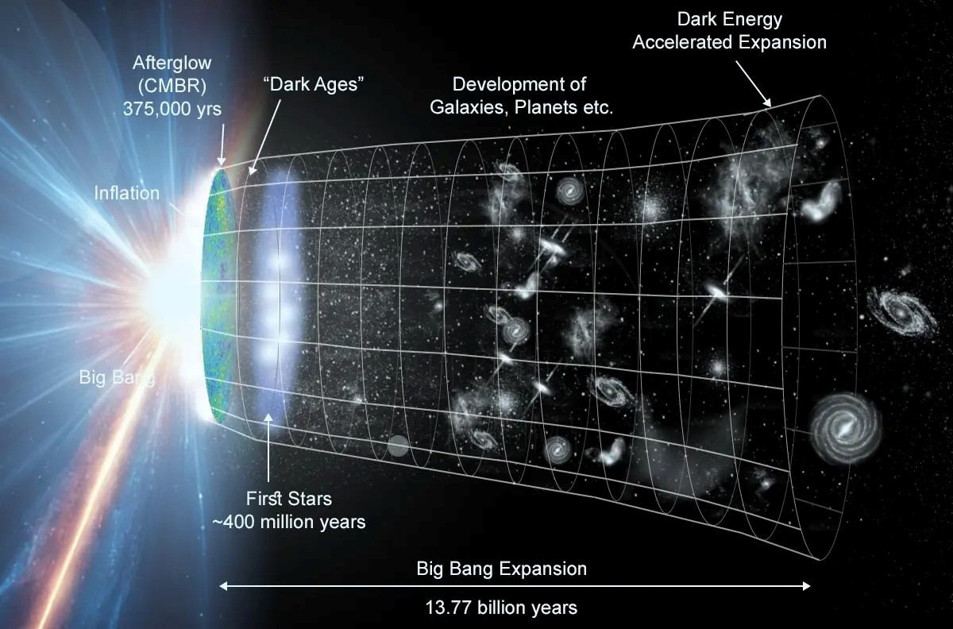

**1.5 Reionization: Exploring the Colorful Transformation of the Universe**

After the universe had undergone the process of recombination, it entered a period often referred to as the “cosmic dark ages.” The universe was still and silent, its newborn hydrogen atoms floating in the cold, dark void. But this quiet wouldn't last forever. The universe was on the brink of another dramatic transformation – the era of reionization.

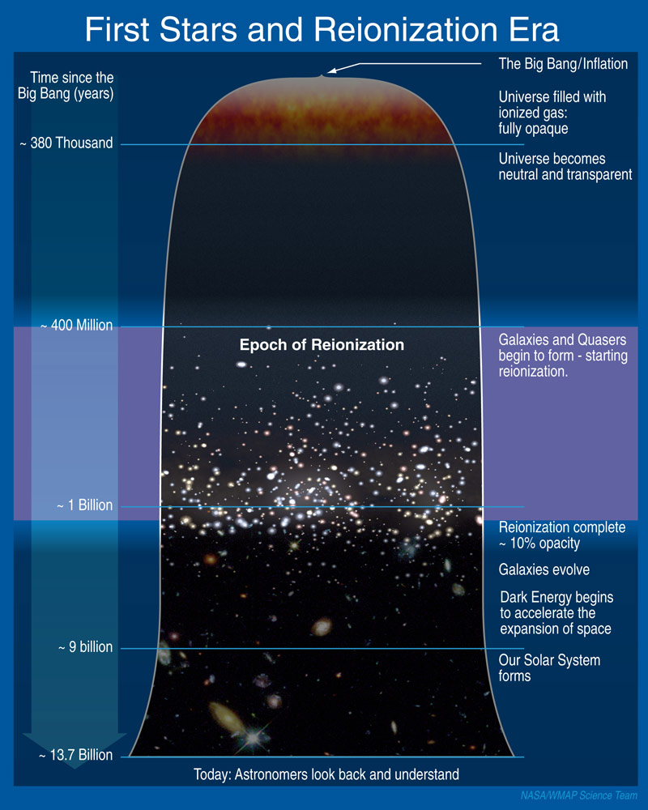Picture the universe in its adolescence: a vast, dark expanse filled with neutral hydrogen atoms. This was a time when the first stars and galaxies were just beginning to flicker into existence, like tiny candles in a pitch-black room. These early stars were unlike anything we see today. They were massive, hot, and intensely bright, blazing with a light that would soon change the universe forever.

As these first stars ignited, they unleashed a torrent of ultraviolet light, powerful enough to start breaking apart the neutral hydrogen atoms that filled the cosmos. This process, known as reionization, was the universe's next big leap – a reawakening that would bathe the cosmos in light once more.

The ultraviolet radiation from these early stars and galaxies began to ionize the surrounding hydrogen atoms, stripping away their electrons and transforming them back into a state of charged particles. Slowly, the universe transitioned from a dark, neutral place into a vibrant, ionized one.

Reionization didn’t happen all at once. It was a patchwork process, with pockets of ionized gas expanding around the first galaxies like bubbles in a cosmic foam. As more and more stars formed, these bubbles grew and 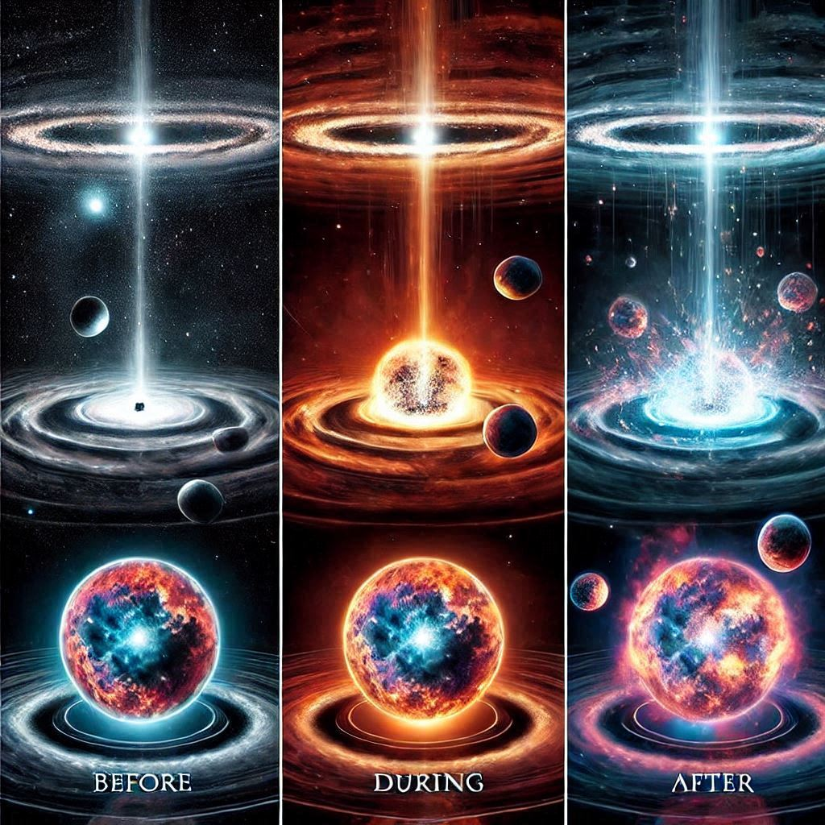merged, eventually reionizing the entire universe. The once-dark cosmos was now a glowing tapestry of light, filled with the first stars, galaxies, and nebulae.

But this transformation was not just about illumination; it was also a time of great change in the structure of the universe. The intense energy released by reionization helped shape the formation of galaxies and other cosmic structures. It was a time of creation and destruction, where the early universe was sculpted into the complex, dynamic place we see today.

The era of reionization was a crucial chapter in the story of the universe. It marked the end of the cosmic dark ages and set the stage for the rich and diverse cosmos that followed. The light from this era, stretching across billions of years, still reaches us today, allowing astronomers to peer back in time and witness the birth of the first cosmic structures.

As the universe continued to expand and evolve, reionization paved the way for the development of galaxies, stars, and ultimately, planets. It was a colorful, transformative time that brought the universe to life, making it the vibrant, dynamic place we are a part of today.

**Chapter 2: Exploring Our Universe**

**2.1 Stars and Constellations: Journey Through the Night Sky**

In the vast tapestry of the night sky, stars twinkle like tiny diamonds scattered across a velvet backdrop. Each one tells a story, shining with a light that has traveled across unimaginable distances to reach our eyes. But these stars aren’t just random dots in the sky—they form patterns, like cosmic connect-the-dots, known as constellations.

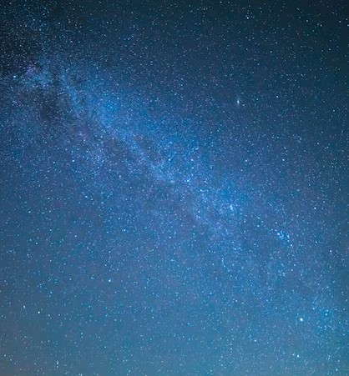Imagine lying on a blanket in a wide-open field, gazing up at the starry sky. As your eyes adjust to the darkness, you begin to see the stars in all their brilliance. Some are bright and bold, while others are faint whispers of light. But if you look closely, you’ll notice something magical: certain stars seem to align, creating shapes and figures in the sky.

These shapes are constellations, and they have been a source of wonder and inspiration for people throughout history. Ancient cultures looked up at the stars and saw the outlines of mythical creatures, legendary heroes, and powerful gods. For example, in Greek mythology, the constellation Orion represents a mighty hunter. His belt, made up of three closely spaced stars, was seen as his hunting belt. The Greeks believed that Orion was placed in the sky by the gods, and his story became a symbol of bravery and skill.

Similarly, in ancient Egypt, the constellation of Osiris was associated with the god of the underworld. The alignment of the pyramids of Giza was linked to the stars of Orion’s Belt. The Egyptians believed that the stars were the souls of their departed pharaohs and used these celestial patterns to guide their burial practices and ceremonies.

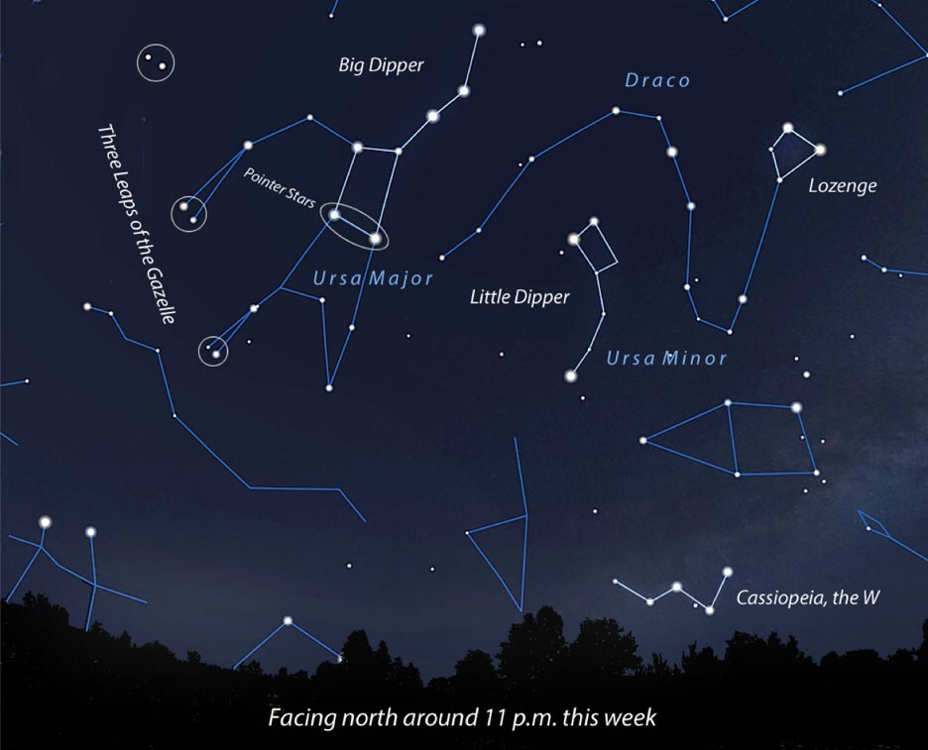But constellations aren’t just pretty pictures; they also served practical purposes. Sailors used them to navigate the vast oceans, and farmers relied on them to mark the changing seasons. The stars were a cosmic calendar, guiding humanity through the rhythms of life.

As you continue to gaze upward, you might notice the most famous constellation of all: the Big Dipper. It looks like a giant spoon hanging in the sky, and it’s part of a larger constellation called Ursa Major, the Great Bear. The two stars at the edge of the Big Dipper’s bowl are called the “pointer stars” because they point directly to Polaris, the North Star. Polaris has been a guiding light for travelers for centuries, always showing the way north.

Stars aren’t just fixed points in the sky. They’re born, live out their lives, and eventually die. Deep in the heart of a star, nuclear reactions churn, turning hydrogen into helium and releasing an immense amount of energy in the process. This energy is what makes stars shine so brightly. Over millions or even billions of years, a star will burn through its fuel, and when it runs out, it faces a dramatic end. Some stars will gently fade away, while others will explode in a brilliant supernova, scattering their material across the cosmos.

When you look up at the stars, you’re not just seeing points of light; you’re witnessing the stories of these distant suns, each with its own life story, written in the language of the universe.

**2.2 Galaxies and Black Holes: Unveil the Secrets of the Cosmic Giants**

Beyond the stars and constellations of our night sky lies a vast, almost unimaginable expanse filled with cosmic giants known as galaxies. These colossal structures are home to billions, even trillions, of stars, along with gas, dust, and mysterious dark matter. But the story of galaxies doesn’t end there—at their hearts, many of them harbor one of the most enigmatic objects in the universe: black holes.

Imagine for a moment that you’re an interstellar explorer, traveling through space at the speed of light. As you journey through the cosmos, you’d come across galaxies of all shapes and sizes. Some, like our own Milky Way, are spirals with graceful, sweeping arms that curl outwards like a cosmic pinwheel. Others are elliptical, smooth and round like giant, glowing orbs, while some are irregular, their shapes distorted by cosmic collisions and interactions.

The concept of galaxies has been part of human imagination for centuries. The term "galaxy" itself comes from the Greek word "galaxias," meaning "milky," referring to the Milky Way—a river of milk spilled across the sky by the goddess Hera, according to ancient Greek mythology.

Galaxies are the cosmic cities of the universe, each one bustling with the activity of countless stars, planets, and other celestial objects. The Milky Way, our home galaxy, is just one of billions, stretching across 100,000 light-years from end to end. It’s a place of stunning beauty and immense scale, containing not only stars but also star clusters, nebulae, and dark matter.

Galaxies come in various shapes and sizes, each contributing to the grand cosmic narrative.

Galaxies are like immense cosmic cities. There are three main types:

Spiral Galaxies: These galaxies have a flat, rotating disk with spiral arms and a central bulge. The Milky Way, our galaxy, is a classic example of a spiral galaxy, with its elegant spiral arms and central bar structure. The stars within a spiral galaxy are distributed in a pattern resembling a spinning pinwheel.

Elliptical Galaxies: These galaxies range from nearly spherical to elongated shapes, with a smooth, featureless light distribution. They often contain older stars and less gas and dust. Elliptical galaxies can vary greatly in size, from dwarf elliptical galaxies to massive giants.

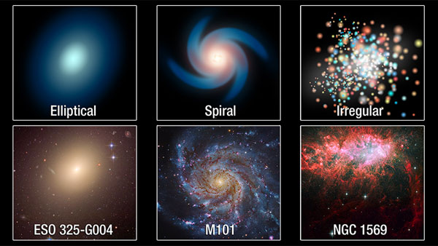Irregular Galaxies: These galaxies lack a distinct shape and appear chaotic. They often have high rates of star formation and are influenced by interactions with other galaxies. Irregular galaxies can be rich in young stars and nebulae.

At the center of many galaxies, including our Milky Way, lies a black hole—a region of space where gravity is so strong that not even light can escape its pull. Black holes are mysterious and fascinating, often depicted in science fiction as cosmic monsters devouring everything in their path.

The idea of black holes was first predicted by Albert Einstein’s theory of general relativity. They have since captured the imagination of scientists and storytellers alike. Black holes come in various sizes. Some are stellar black holes, formed from the remnants of massive stars that have exploded in supernovae. Others are supermassive black holes, which can be billions of times the mass of our Sun, found at the centers of galaxies. These supermassive black holes are thought to play a key role in the formation and evolution of galaxies.

The gravitational pull of a black hole is so intense that it warps the fabric of space and time around it, creating a cosmic whirlpool. Anything that ventures too close to a black hole is pulled in, never to escape. However, black holes are not cosmic vacuum cleaners; they don’t suck in everything around them. Their effects are noticeable only when objects venture too close to their event horizon, the boundary beyond which escape is impossible.

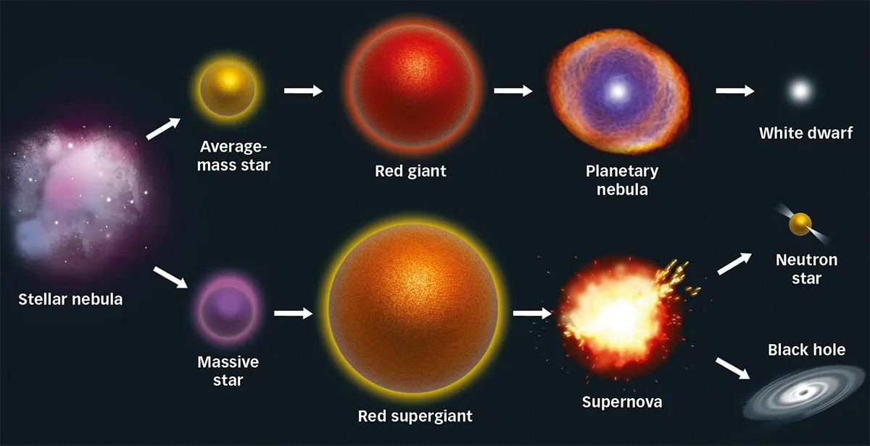

Black holes are formed when massive stars collapse under their own gravity at the end of their life cycles.

There are different types of black holes:

Stellar Black Holes: Formed from the remnants of massive stars after a supernova explosion, these black holes typically have masses ranging from a few to several tens of times that of the Sun.

Supermassive Black Holes: Found at the centers of most galaxies, including the Milky Way, these black holes contain millions or billions of times the mass of the Sun. They play a crucial role in galaxy formation and evolution.

Black holes have a profound impact on their surroundings. Their intense gravity can warp space and time, creating what is known as the event horizon—the point beyond which nothing can return. The material falling into a black hole forms an accretion disk, which heats up and emits X-rays, making black holes detectable by telescopes.

The concept of black holes has evolved from John Michell's idea of “dark stars” in the 18th century to the more sophisticated models we have today. The term “black hole” was coined by physicist John Archibald Wheeler in the 1960s.

**2.3 Moons and Planets: Visit the Diverse Worlds in Our Solar System**

In our solar system, planets and moons are like distant, intriguing worlds waiting to be explored. Each one has its own unique features, making them fascinating destinations in the grand cosmic adventure.

Imagine you’re a space traveler, embarking on a journey through our solar system. Your first stop might be Mercury, the closest planet to the Sun. Mercury is a tiny, rocky world, scorched by the Sun’s heat. It’s a place where daytime temperatures can soar to over 800 degrees Fahrenheit (430 degrees Celsius), while nights can plunge to -330 degrees Fahrenheit (-200 degrees Celsius).

Next, you might visit Venus, a planet shrouded in thick clouds of sulfuric acid. Venus is often called Earth’s twin because of its similar size, but its surface is an inferno, with temperatures hot enough to melt lead. Despite this, Venus has been a source of fascination and inspiration in human culture, often symbolizing beauty and desire in ancient mythology.

Moving outward, you reach our home planet, Earth. Earth is unique in its ability to support life, thanks to its water, atmosphere, and moderate temperatures. The Earth’s Moon, our constant companion, has been a source of wonder throughout history. Ancient cultures used the Moon to mark time, with months and calendars based on its phases.

The Moon has a rich place in mythology. For example, in Roman mythology, the Moon was personified as Luna, a goddess who drove her chariot across the night sky. The phases of the Moon were used to guide agricultural practices and track the seasons.

Beyond Earth, you’ll encounter Mars, often called the Red Planet due to its reddish appearance. Mars has fascinated astronomers and scientists for centuries with its similarities to Earth. With its polar ice caps and evidence of ancient rivers, Mars is a key focus in the search for extraterrestrial life.

Jupiter, the largest planet in our solar system, is a gas giant with a swirling storm system. The Great Red Spot is a massive storm that has raged for centuries. Jupiter’s many moons, including the largest moon Ganymede, offer a glimpse into a diverse range of celestial bodies.

Saturn, with its stunning rings, is a sight to behold. Its rings are made of ice and rock particles and create a dazzling display. Saturn’s moons, like Titan, have atmospheres and lakes of liquid methane, making them intriguing subjects for scientific study.

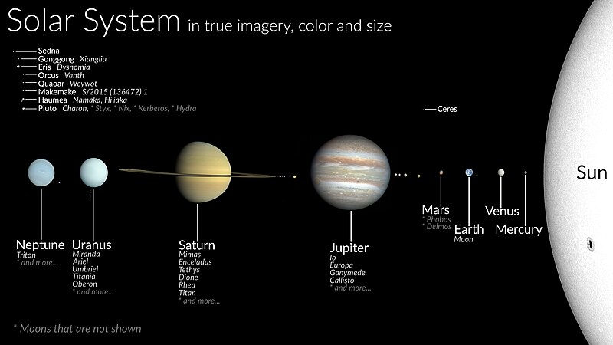Uranus and Neptune, the ice giants, complete our solar system. Uranus rolls on its side as it orbits the Sun, while Neptune, the farthest planet, boasts fierce winds and a deep blue color.